Deploy VBooks Application on tomcat
Project: VBooks

Project Id: VT001

Prerequisites
JAVA
Java must be installed (jdk 1.5 or later version)
Tomcat
Apache-tomcat-6 must be installed
MySQL Server
MySQL database server must be installed

Configure MySQL Server
As a mysql root user Create a database v_books
mysql>create database v_books;
Create a mysql user v_books.
mysql>create user vbooks;
Grant all privileges to user vbooks on database v_books.
mysql>grant all on v_books.* to vbooks@localhost identified by 'vbooks123';
mysql>flush privileges;
Create table in v_books database using scripts provided.
#mysql -u vbooks -pvbooks123 v_books<sql/create.sql
Dump default data to database v_books using script
#mysql -u vbooks -pvbooks123 v_books<sql/auth.sql

Deploy Application
Copy Application war file to weapps directory in tomcat
#cp /path/to/application/v-books.war ~/Application/apache-tomcat-6.x.x/webapps/
Change directory to ~/Application/apache-tomcat-6.x.x/bin
#cd ~/Application/apache-tomcat-6.x.x/bin
Start the tomcat
#./startup.sh
After start the tomcat open http://localhost:8080/v-books
You will get below Application login page

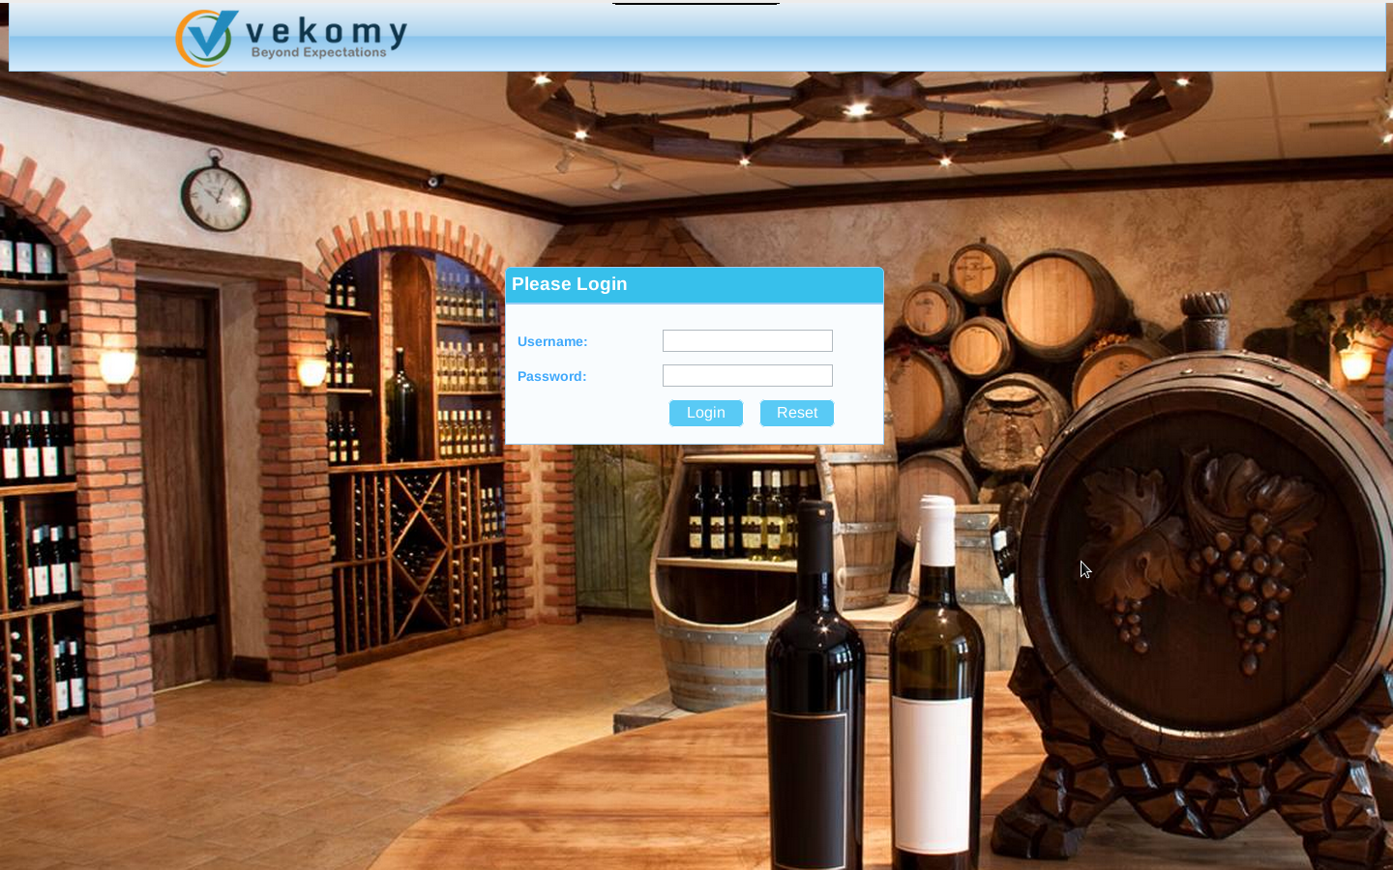

Fail over Recovery
Remove the war file v-books.war available in ~/Application/apache-tomcat-6.x.x/webapps/
Drop Database v_books from MySQL Database.

